**MOM-Catero**

The Catero team worked on a commercial purpose to meet the need of our Customer who wants to start a catering website for their catering service which is being run successfully from many years.

The development team have always been actively interacting with our client since the very beginning of our project. We’ve been interacting with our customer through phone calls and emails and Skype calls. We also shared with him the details of every improvement at every point. We were also glad that our customer is excited with what we are doing and he is looking forward to get started with website of his own of his catering service. Here below we are sharing some of the screenshots and email.

**Phone Calls log with Client:**

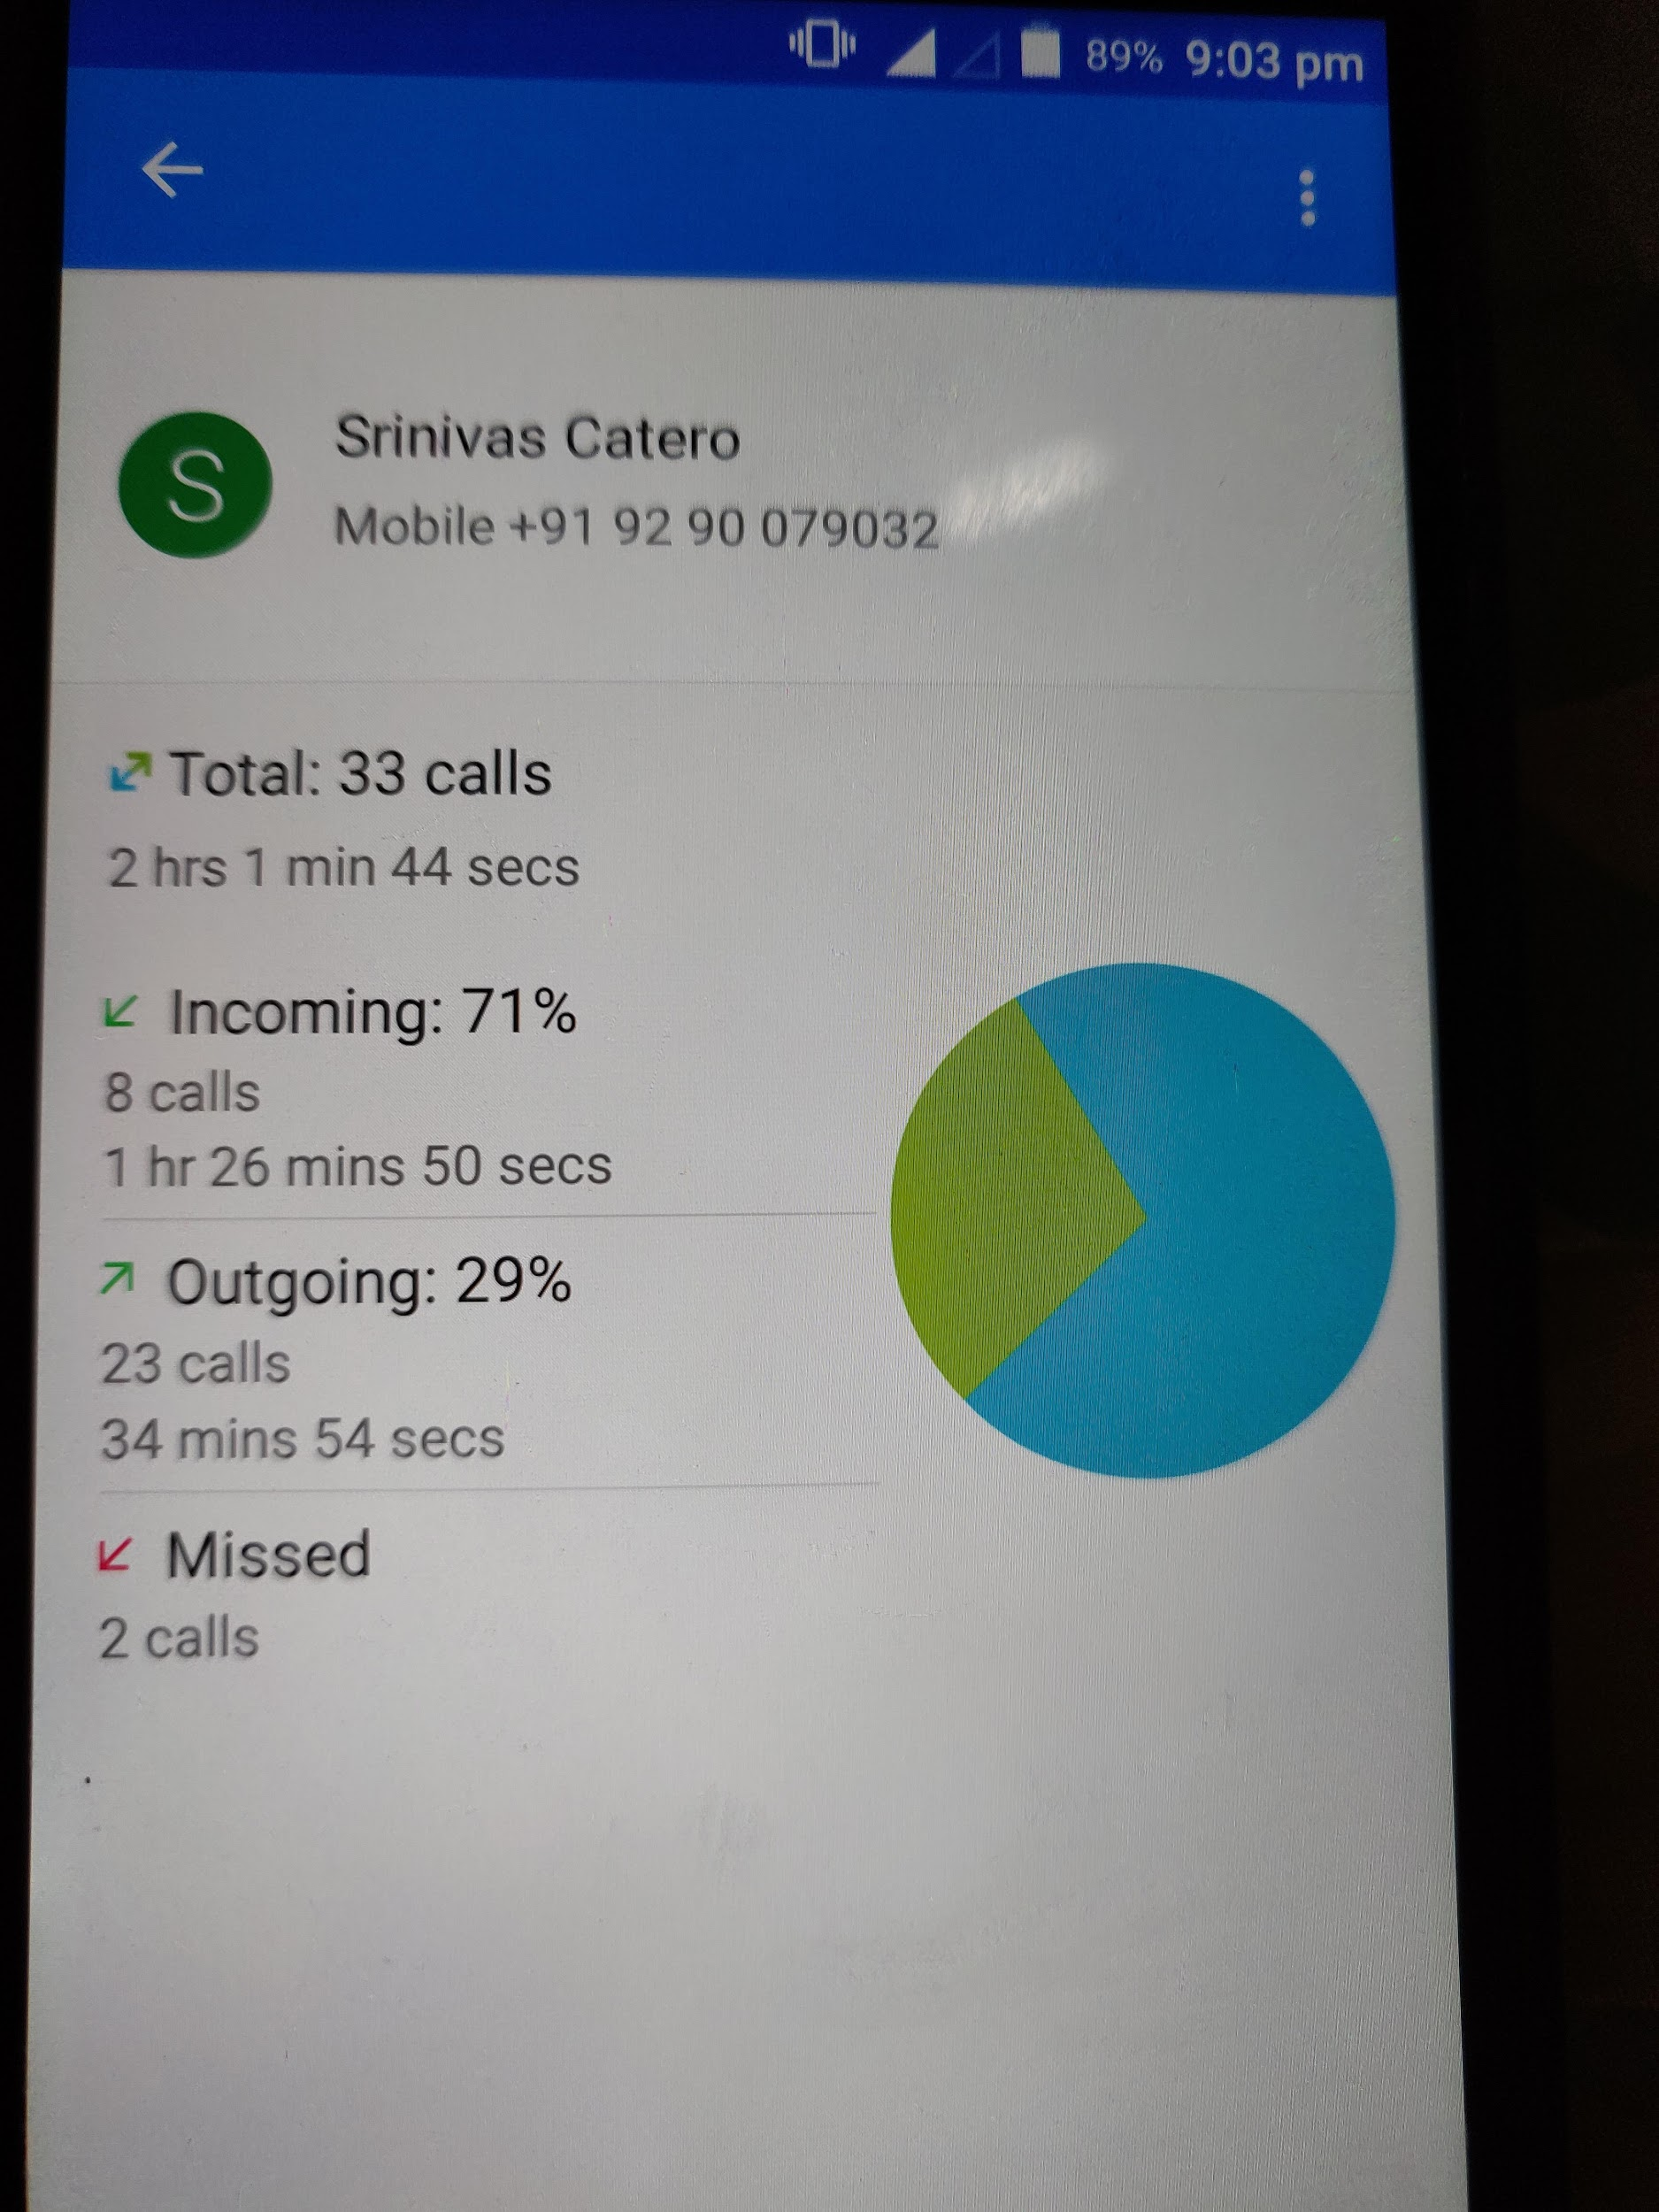

**Screenshot of Mail Confirmation by Client:**

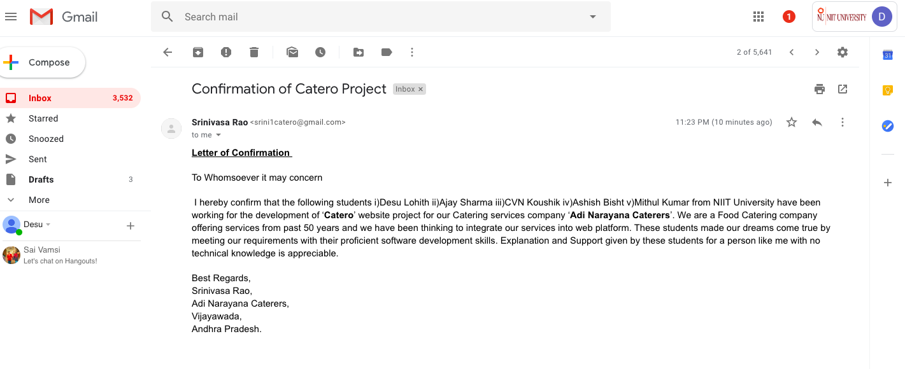

**Video call screen shots**

